Clean Code or:

How to care for code

The Book

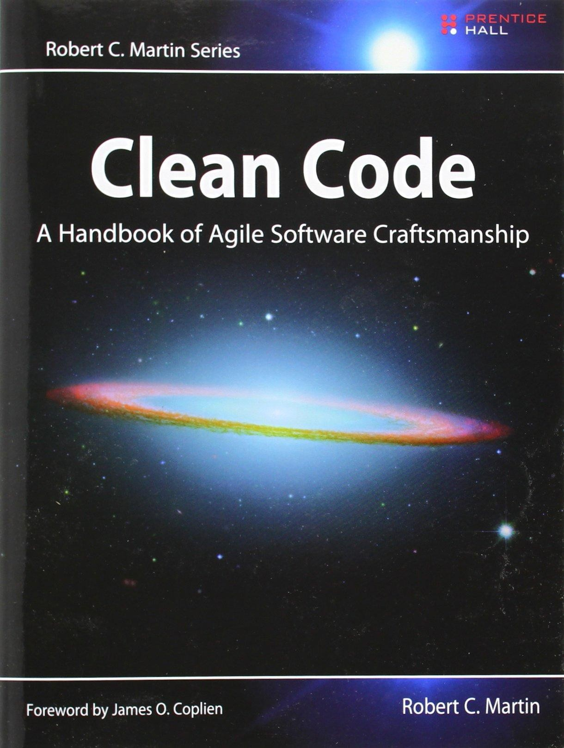

▷ You are a programmer

▷ You want to be a better programmer

▷ On average, 80% of all software work is maintenance

▷ On average, 90% of coding time is spent reading code

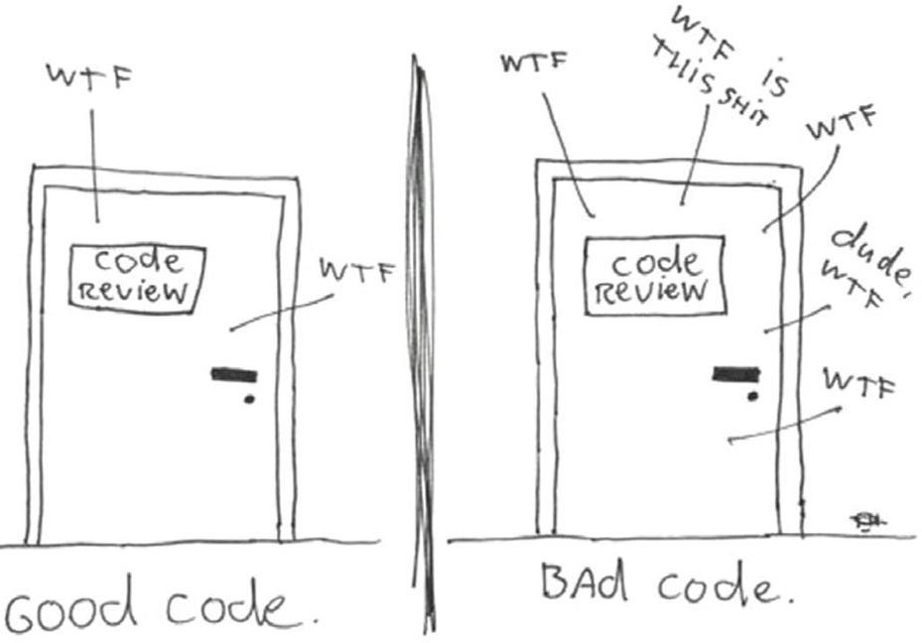

▷ Hard to understand and test

▷ Even harder to extend or maintain

▷ Prolongs release cycles

▷ Delays new features

▷ Ends with *The Grand Redesign in the Sky*

▷ Short deadlines / overall workload too great

▷ Changing requirements

▷ It’s ugly but it works

▷ I didn’t write it, why should I fix it?

▷ I know it’s a mess, I’ll fix it later (LeBlanc’s law: *Later equals never*)



▷ More than just the knowledge of principles and patterns

▷ Read lots of code and think hard about its good and bad sides

▷ Refactor mercilessly until you are satisfied with the result

▷ Can be read, and enhanced by any coder

▷ Has unit and acceptance tests

▷ Has meaningful names

▷ Minimal duplication

▷ Provides a clear and minimal API

▷ Is literate

# The Boy Scout Rule

▷ Code tends to degrade over time

▷ Entropy must be actively fought

▷ Leave the module cleaner than you found it

# Names

Names

▷ Everywhere in software - variables, functions, arguments, classes, and packages, source files, executable files and the directories that contain them

▷ Since we name so much, we’d better do it well

# Intention-Revealing Names

**“**

The name of a variable, function, or class,

should answer all the big questions. It should tell you why it exists, what it does, and how it is used. If a name requires a comment, then the name does not reveal its intent.

~ Robert C. Martin, *Clean Code*

int d; // elapsed time in days

// better, but still not clear enough int elapsedTimeInDays;

// much clearer now int daysSinceCreation;

int daysSinceModification; int fileAgeInDays;

public List<int[]> getThem() { List<int[]> list1 = new ArrayList<>(); for (int[] x : theList)

if (x[0] == 4) list1.add(x); return list1;

}

// more meaningful:

public List<int[]> getFlaggedCells() { List<int[]> flaggedCells = new ArrayList<>(); for (int[] cell : gameBoard)

if (cell[STATUS_VALUE] == FLAGGED)

flaggedCells.add(cell); return flaggedCells;

}

// even more meaningful:

public List<Cell> getFlaggedCells() { List<Cell> flaggedCells = new ArrayList<>(); for (Cell cell : gameBoard)

if (cell.isFlagged()) flaggedCells.add(cell);

return flaggedCells;

}

# Use Meaningful Distinctions

public static void copyChars(char a1[], char a2[]) { for (int i = 0; i < a1.length; i++) {

a2[i] = a1[i];

}

}

// easy to see what is what

public static void copyChars(char source[], char destination[]) {

for (int i = 0; i < source.length; i++) { destination[i] = source[i];

}

}

# Use Pronounceable Names

class DtaRcrd102 { private Date genymdhms; private Date modymdhms;

private final String pszqint = ”102”;

}

class Customer {

private Date generationTimestamp; private Date modificationTimestamp;; private final String recordId = ”102”;

}

▷ Single letter-variables and number constants are not easily searched

▷ Modern IDEs allow you to find usages of a variable but number constants are harder

for (int j=0; j < 34; j++) { s += (t[j] * 4) / 5;

}

// can be better represented as

static final int NUMBER_OF_TASKS = 34; static final int WORK_DAYS_PER_WEEK = 5; static final int REAL_DAYS_PER_IDEAL_DAY = 4; int sum = 0;

for (int j=0; j < NUMBER_OF_TASKS; j++) { int realTaskDays = taskEstimate[j] *

REAL_DAYS_PER_IDEAL_DAY;

int realTaskWeeks = realTaskDays /

WORK_DAYS_PER_WEEK;

sum += realTaskWeeks;

}

▷ Avoid prefixing interfaces with I

* ShapeFactory vs. IShapeFactory

▷ Classes and objects should have noun or noun phrase names

* Customer, WikiPage, Account, and AddressParser
* Too general names like Data, Info and Processor to be used only if no better option is present

▷ Methods should have verb or verb phrase names

* *postPayment*, *deletePage*, or save
* accessors, mutators, and predicates should be named for their value and prefixed with get, set, and is according to the javabean standard.

▷ People who read your code will be programmers - use computer science terms, algorithm and pattern names freely

* *TemplateFactory, MessageHandlerStrategy, QuickSortSorter*

▷ Use problem domain names to better relate the purpose of your code

* *MessageRouter, AccountHolder, FacebookProfile*

▷ Hungarian notation and other type encodings are unnecessary in modern IDEs and are only a source of code clutter

▷ Variable prefixes are also obsolete since modern IDEs can be configured to format the variables differently based their scope

Hungarian notation:

PhoneNumber phoneString;

// name not changed when type changed!

Member prefixes:

public class Part {

private String m_dsc; // The textual description

void setName(String name) { m_dsc = name;

}

}

~~Hungarian notation:~~

PhoneNumber phoneNumber;

~~Member prefixes:~~

public class Part { private String name;

void setName(String name) { this.name = name;

}

}

# Functions

▷ The first line of organization in any program

▷ Containers of logic

public static String testableHtml(

PageData pageData, boolean includeSuiteSetup

) throws Exception {

WikiPage wikiPage = pageData.getWikiPage(); StringBuffer buffer = new StringBuffer(); if (pageData.hasAttribute("Test")) {

if (includeSuiteSetup) { WikiPage suiteSetup =

PageCrawlerImpl.getInheritedPage( SuiteResponder.SUITE_SETUP_NAME, wikiPage);

if (suiteSetup != null) { WikiPagePath pagePath = suiteSetup

.getPageCrawler()

.getFullPath(suiteSetup); String pagePathName =

PathParser.render(pagePath);

buffer.append("!include -setup.")

.append(pagePathName).append("\n");

}

}

WikiPage setup = PageCrawlerImpl

.getInheritedPage("SetUp", wikiPage); if (setup != null) {

WikiPagePath setupPath = wikiPage

.getPageCrawler().getFullPath(setup); String setupPathName =

PathParser.render(setupPath); buffer.append("!include -setup .")

.append(setupPathName).append("\n");

}

}

buffer.append(pageData.getContent()); if (pageData.hasAttribute("Test")) {

WikiPage teardown = PageCrawlerImpl

.getInheritedPage("TearDown", wikiPage);

if (teardown != null) {

WikiPagePath tearDownPath = wikiPage

.getPageCrawler().getFullPath(teardown); String tearDownPathName = PathParser

.render(tearDownPath); buffer.append("\n")

.append("!include -teardown .")

.append(tearDownPathName).append("\n");

}

if (includeSuiteSetup) {

WikiPage suiteTeardown = PageCrawlerImpl.getInheritedPage( SuiteResponder.SUITE_TEARDOWN_NAME,wikiPage);

if (suiteTeardown != null) {

WikiPagePath pagePath = suiteTeardown

.getPageCrawler()

.getFullPath(suiteTeardown); String pagePathName = PathParser

.render(pagePath); buffer.append("!include -teardown .")

.append(pagePathName).append("\n");

}

}

}

pageData.setContent(buffer.toString()); return pageData.getHtml();

}

▷ Function is too long

▷ Lots of code duplication

▷ Name not clear enough

▷ Control flow too complex

* too many nested ifs

public static String renderPageWithSetupsAndTeardowns( PageData pageData, boolean isSuite

) throws Exception {

boolean isTestPage = pageData.hasAttribute("Test"); if (isTestPage) {

WikiPage testPage = pageData.getWikiPage(); StringBuffer newPageContent = new StringBuffer(); includeSetupPages(testPage, newPageContent, isSuite); newPageContent.append(pageData.getContent()); includeTeardownPages(testPage, newPageContent, isSuite); pageData.setContent(newPageContent.toString());

}

return pageData.getHtml();

}

# Functions - example cleanest

public static String renderPageWithSetupsAndTeardowns(

PageData pageData, boolean isSuite) throws Exception {

if (pageData.isTestPage()) includeSetupAndTeardownPages(pageData,

isSuite);

return pageData.getHtml();

}

▷ The first rule of functions is that they should be small.

▷ The second rule of functions is that they should be smaller than that.

▷ Functions

* should do one thing
* should do it well
* should do it only

▷ Very high level of abstraction

test.createHtml()

▷ Intermediate level of abstraction

PathParser.render(pagePath)

▷ Low level

buffer.append(text)

▷ They rarely do only one thing

▷ They are rarely small

▷ They tend to propagate throughout the code

▷ They usually indicate bad architecture

class Employee... int payAmount() {

switch (getType()) {

case EmployeeType.ENGINEER: return _monthlySalary;

case EmployeeType.SALESMAN:

return _monthlySalary + _commission; case EmployeeType.MANAGER:

return _monthlySalary + _bonus; default:

throw new Exception("Incorrect

Employee");

}

}

▷ Replace them with an appropriate pattern

* AbstractFactory, Strategy, etc.

▷ Replace them with enums

* Java enums can implement interfaces

▷ Replace them with configuration

* maps, properties, xml, etc.

abstract class Employe

abstract int payAmount(Employee emp);

class Salesman

int payAmount(Employee emp) { return emp.getMonthlySalary() +

emp.getCommission();

}

class Manager

int payAmount(Employee emp) { return emp.getMonthlySalary() +

emp.getBonus();

}

class EmployeeFactory {

EmployeeType createEmployeeByType(String type) { switch(type) {

case MANAGER:

return new ManagerEmployee();

/*...*/

}

}

}

▷ More arguments means

* more difficult to understand
* more difficult to test
* often does more than one thing
* often not simple enough

▷ Fix by using Parameter Object / Method Object refactorings

▷ Idealy have no arguments (niladic)

▷ One argument (monadic) or two (dyadic) also acceptable

▷ Three arguments (triadic) to be avoided where possible

▷ Over three (polyadic) should never be used

// Easy to test and comprehend file.exists()

page.getHtml() employee.calculateMonthlyPay()

# Monadic form

//questions

boolean fileExits(String filePath)

// transformations

StringBuffer encodeToBase64(StringBuffer in)

// events

void passwordFailedNTimes(int times)

//setters or flags

void setVisible(boolean isVisible)

# Dyadic form

writeField(name)

// is easier to understand than writeField(outputStream, name)

// perfectly reasonable Point p = makePoint(0, 0)

# Triadic form

// bad but needed assertEquals(message, expected, actual)

// can be replaced by fluent API

assertThat(actual).describedAs(message)

.isEqualTo(expected)

// possible to extract Parameter/Method Object Circle makeCircle(double x, double y, double r); Circle makeCircle(Point center, double r); Circle CircleCenter#makeCircle(double r);

# Apply Verbs To Key Words

write(String fieldName)

// not as clean as writeField(String fieldName)

assertEquals(expected, actual)

// not as clean as assertExpectedEqualsActual(expected, actual)

▷ Misleading

▷ Violates the Do One Thing Rule

▷ Often introduces temporal coupling / function call order dependencies

* method b must be called after method a but before method c

▷ Arguments naturally interpreted as inputs

▷ Output arguments predate OOP

▷ In OO languages this object to be preferred over output arguments

* make the output argument a field

▷ Duplication: the root of all evil in software

▷ Difficult to modify / extend

* every duplicate must be tracked down and changed, some may be overlooked

▷ Difficult to troubleshoot

▷ Goes against OO principles

* different abstractions shouldn’t do the same thing

# Classes

Small!

▷ The first rule of classes is that they should be small.

▷ The second rule of classes is that they should be smaller than that.

▷ The measure of size is not the number of lines but the number of responsibilities

# Single Responsibility Principle

▷ A class (or module) should have one and only one reason to change

▷ Describe the class in 25 words without using “if,” “and,” “or,” or “but.”

* if impossible, the class violates SRP

▷ Produces a large number of small, single- purpose classes

* easier to test, maintain and understand

# Small enough?

public class SuperDashboard extends JFrame {

public Component getLastFocusedComponent(){/**/} public void setLastFocused(

Component lastFocused){/**/}

|  |  |  |
| --- | --- | --- |
| public | int | getMajorVersionNumber(){/**/} |
| public | int | getMinorVersionNumber(){/**/} |
| public  } | int | getBuildNumber(){/**/} |

# Small enough!

public class Version {

|  |  |  |
| --- | --- | --- |
| public | int | getMajorVersionNumber(){/**/} |
| public | int | getMinorVersionNumber(){/**/} |
| public  } | int | getBuildNumber(){/**/} |

public class FocusableDashboard extends JFrame { public Component getLastFocusedComponent(){/**/} public void setLastFocused(

Component lastFocused){/**/}

}

▷ Classes should have a small number of instance variables

▷ Methods of a class should manipulate one or more of those variables

▷ The more variables a method manipulates the more cohesive that method is to its class

▷ If each field is used by each method the class is maximally cohesive

* Rarely seen in practice

▷ Bad cohesion can sometimes indicate that a class should be split up into several smaller classes

public class GoodCohesionStack { private int topOfStack = 0;

List<Integer> elements = new LinkedList<Integer>(); public int size() { return topOfStack; }

public void push(int element) { topOfStack++; elements.add(element);

}

public int pop() throws PoppedWhenEmpty { if (topOfStack == 0)

throw new PoppedWhenEmpty();

int element = elements.get(--topOfStack); elements.remove(topOfStack);

return element;

}

}

# Error Handling

▷ Error Codes

* Relics of old programming languages
* Lead to deeply nested if statements
* Create dependency magnets
* Require callers to check returns of every call
* Difficult to separate happy path from error handling
* Difficult to externalize error handlers

if (deletePage(page)==E_OK)

if (registry.deleteReference(page.name)==E_OK) if (configKeys.deleteKey(page.key)==E_OK)

// do something else // handle error

else // handle error else return E_ERROR;

try { deletePageAndAllReferences(page);

} catch (Exception e) { handleError(e);

}

private void deletePageAndAllReferences(Page page) { deletePage(page); registry.deleteReference(page.name); configKeys.deleteKey(page.key);

}

private void handleError(Exception e) {

// handle error or errors

}

▷ Checked exceptions

* Useful only in mission-critical libraries
* Generally do not increase robustness of software
* Break encapsulation
* Cause widespread boilerplate try-catch blocks
* Cause cascading throws declarations throughout the call hierarchy

▷ Write wrapper classes around library calls and translate checked exceptions into unchecked

○

ACMEPort port = new ACMEPort(12); try {

port.open();

} catch (DeviceResponseException e) { reportPortError(e);

logger.log(“Device response exception”, e);

} catch (ATM1212UnlockedException e) { reportPortError(e); logger.log(“Unlock exception”, e);

} catch (GMXError e) { reportPortError(e);

logger.log(“Device response exception”);

} finally { /* … */}

// Wrapper class

LocalPort port = new LocalPort(12);

try { port.open();

} catch (PortDeviceFailure e) {

// Wrapped unchecked exception reportError(e); logger.log(e.getMessage(), e);

} finally { /* … */ }

public class LocalPort { private ACMEPort innerPort;

/* … */

public void open() { try {

innerPort.open();

} catch (DeviceResponseException e) { throw new PortDeviceFailure(e);

} catch (ATM1212UnlockedException e) { throw new PortDeviceFailure(e);

} catch (GMXError e) {

throw new PortDeviceFailure(e);

}

}

}

▷ Stack trace is often not enough

▷ Provide meaningful error messages

▷ If needed, also provide erroneous data

▷ Mention the operation that failed and the type of failure

○

▷ Returning Nulls

* Forces callers to perform null-checks
* Lowers overall code robustness

▷ Return empty arrays/collections/strings

▷ Use the Special Case pattern

* Subclasses of the expected return type that implement the special “empty” behavior

# Objects and Data Structures

▷ Objects

* Hide their data behind abstractions and expose functions that operate on that data

▷ Data structures

* Expose their data and have no meaningful functions

▷ Both have equally valid uses

* Even in OO languages

▷ Fewer dependencies

▷ Easier to refactor classes and add or remove variables

▷ Focus is on abstractions and valid operations

▷ Less clutter

▷ Easier to enforce access rules

▷ Easier to provide thread-safety

▷ Method *m* of class *C* should only call methods

* of *C* or of *C’s* fields
* of objects created by *m*
* of objects passed as arguments to *m*

▷ Code that violates the Law is called a train wreck

* ctxt.getOptions().getScratchDir().getPath();

▷ Does not apply to data structures

# Comments

▷ Necessary evil to be used sparingly

* More often than not, just a source of code clutter

▷ Don’t make up for bad code

* Don’t comment bad code, refactor it

▷ Shouldn’t be used to track changes

* Use a CVS like GitHub or Bitbucket instead

▷ Shouldn’t be used to hide unused code

* Delete the code instead

▷ Shouldn’t be used to convey information already present in the code

▷ Explain Yourself in Code

* // Is employee eligible for full benefits?
* if (employee.flags & HOURLY_FLAG &&
* employee.age > 65)
* if (employee.isEligibleForFullBenefits())

▷ Legal comments

* e.g. GNU licence declaration

▷ Public library/framework code documentation

* JavaDocs API documentation

▷ Complex algorithm explanation

▷ Warnings and limitations

* e.g. thread-safety, serialization issues

▷ TODO comments

# Questions?

Suggested reading

▷ **Clean Code: A Handbook of Agile Software Craftsmanship**, Robert

C. Martin, Prentice Hall, 2008.

▷ **The Clean Coder: A Code of Conduct for Professional Programmers**, Robert C. Martin, Prentice Hall, 2011.

▷ **Design Patterns: Elements of Reusable Object Oriented Software**, Gamma et al., Addison-Wesley, 1996.

▷ **Refactoring: Improving the Design of Existing Code**, Martin Fowler et al., Addison-Wesley, 1999.

▷ **The Pragmatic Programmer**, Andrew Hunt, Dave Thomas, Addison- Wesley, 2000.

▷ **Domain Driven Design**, Eric Evans, Addison-Wesley, 2003.

▷ **Agile Software Development: Principles, Patterns, and Practices**, Robert C. Martin, Prentice Hall, 2002.

Thank you!